C H E E S Y G A R L I C

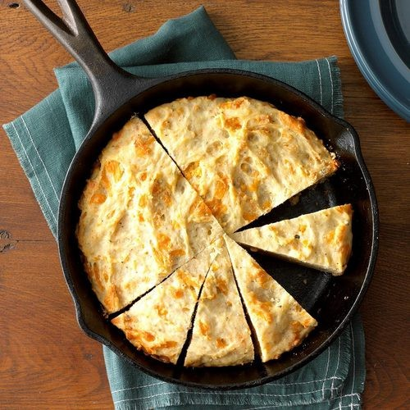
H E R B Q U I C K B R E A D

Ingredients:

3 cups all-purpose flour 3 tablespoons sugar
1 tablespoon baking powder
2 teaspoons Italian seasoning 1 teaspoon garlic powder
1/2 teaspoon salt
1 large egg, room temperature 1 cup milk
1/3 cup canola oil
1 cup shredded sharp cheddar cheese

Instructions:

preheat oven to 350°. In a large bowl, whisk together first 6 ingredients. In another bowl, whisk together egg, milk and oil. Stir in cheese and add to flour mixture; stir just until moistened.
Spoon batter into a greased 9-in. cast-iron skillet and bake at 350° until a toothpick inserted in center comes out clean, 25-30 minutes.
Let cool and serve!

