C H O C O L A T E P I E

Ingredients:

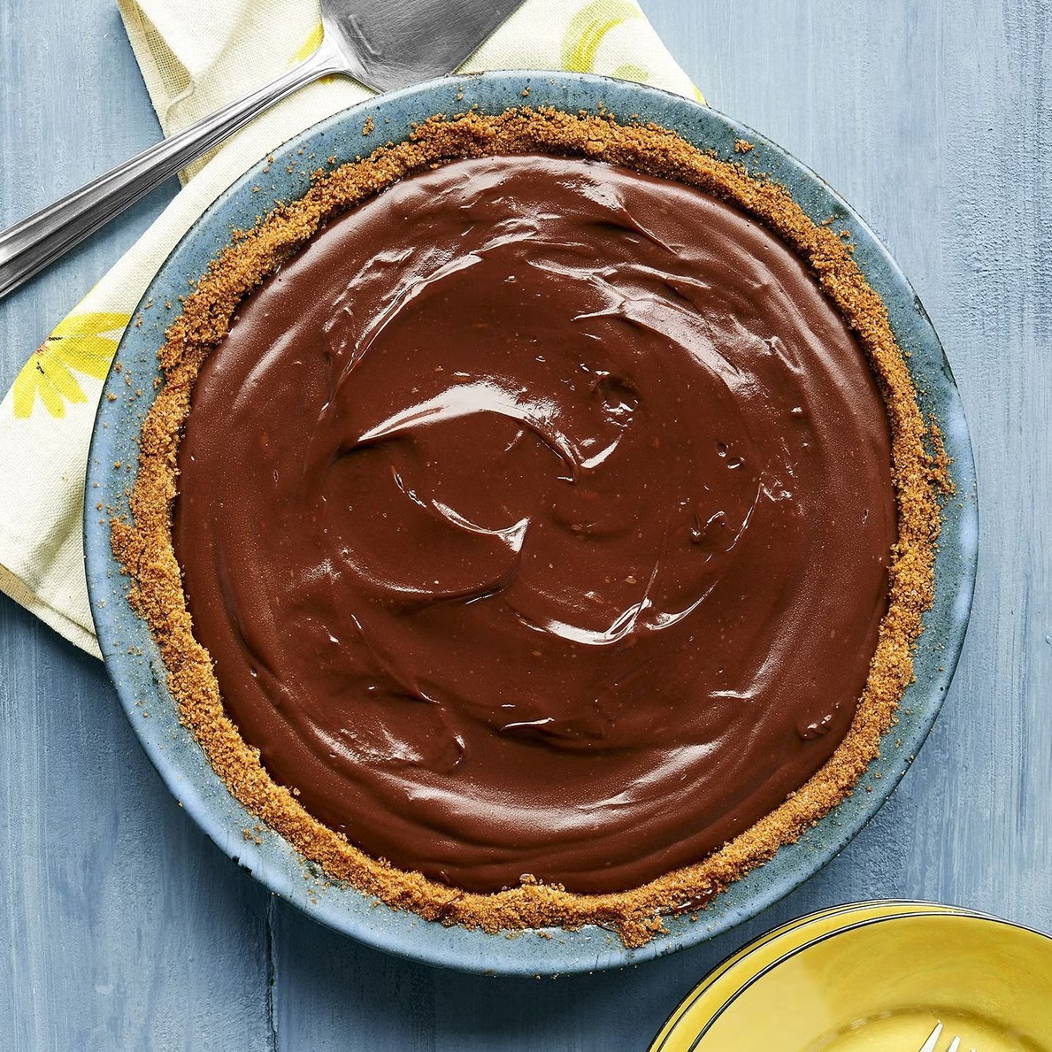
1 1/2 cups sugar
1/4 cup cornstarch 1/4 tsp. salt
3 cups whole milk
4 egg yolks
6 1/2 oz. bittersweet chocolate, finely chopped
2 tsp. vanilla extract 2 Tbsp. butter
pie crust, baked and cooled (or can use Oreo or graham cracker crust)
Whipped cream, to serve

Instructions:

In a medium saucepan, stir or whisk together the sugar, cornstarch, and salt. Pour in the milk and egg yolks, whisking to combine.
Stir over medium heat until the mixture just barely comes to a boil and becomes thick, about 6 to 8 minutes (maybe less, maybe more; just watch it). The second it starts to bubble and thicken (it should be thick like pudding), remove it from the heat. Add the chocolate, vanilla, and butter, and stir until everything is beautifully combined.
Pour the pudding into the pie crust (if there is extra, spoon it into small dishes) and place in the fridge, uncovered, to chill for 4 hours.
Cut it into slices and serve with whipped cream!

