E A S Y C R E A M C H E E S E

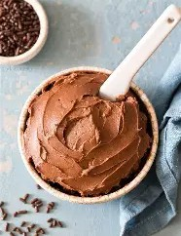
F R O S T I N G

Ingredients:

1 cup semisweet chocolate chips
¼ cup heavy whipping
cream
¼ cup confectioners' sugar
1 (8 ounce) package cream cheese

Instructions:

In a double boiler, melt chips and add heavy cream. Mix until smooth and take off of heat.
In a mixing bowl cream together sugar and cream cheese until smooth. Slowly add chocolate mixture. Mixture will thicken up as chocolate cools.
Use to frost cakes or cupcakes or serve with graham crackers.

