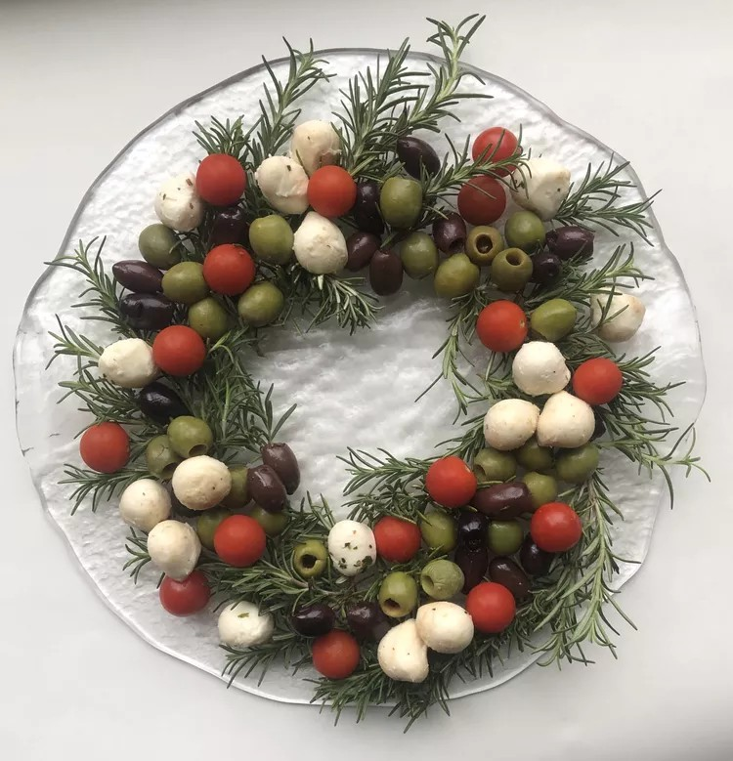
F E S T I V E O L I V E A N D C H E E S E A P P I T I Z E R

Ingredients:

24 sprigs fresh rosemary
12 ounces marinated mozzarella balls, drained
½ cup pitted Castelvetrano olives,
rinsed and dried
¼ cup pitted Kalamata olives, rinsed and drained
¼ cup sugar plum tomatoes

Instructions:

Arrange rosemary sprigs in a 10-inch-diameter circle to resemble a wreath. Start by placing one sprig at a 45-degree angle with the leafy tip facing outwards. Continue adding sprigs in the same direction until you have formed a full circle.
Arrange clusters of mozzarella balls, olives, and tomatoes over rosemary sprigs.
Set out with toothpicks to enjoy!

