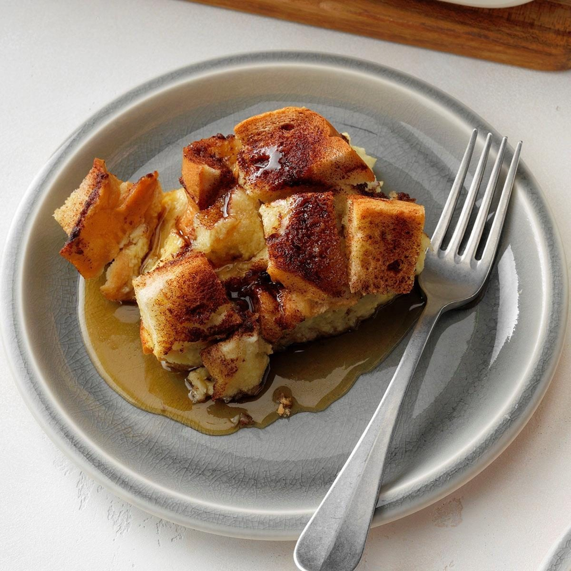
F R E N C H T O A S T C A S S E R O L E

Ingredients:

1 loaf of French bread cut into cubes 8 large eggs lightly beaten
3 cups milk
4 tsp sugar
1 tsp vanilla extract
¾ tsp salt Topping
2 tbsp butter
3 tbsp sugar
2 tsp ground cinnamon maple syrup (optional)
Instructions:

Place bread cubes in a greased 13 x 9 in. baking dish.
In a large bowl, whisk the eggs, milk, sugar, vanilla, and salt. Pour over bread, cover and refrigerate for 8 hours or overnight.
Remove from refrigerator 30 minutes before baking. Preheat oven to 350°.
Dot with butter, combine sugar and cinnamon, sprinkle over the top.
Cover and bake until a knife inserted in the center comes out clean, 45-50 minutes.
Let stand for 45-50 minutes, serve and enjoy!

