P A R M E S A N M A S H E D P O T A T O E S

Ingredients:

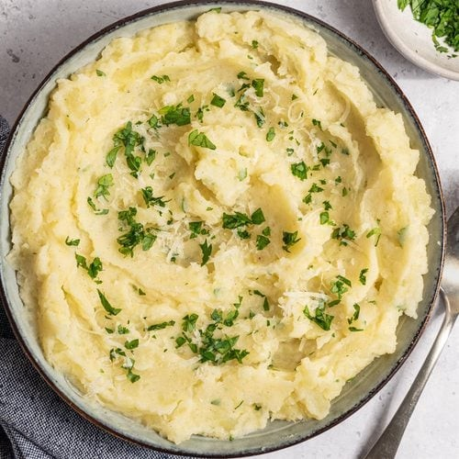
5 pounds potatoes, peeled and cut into 1-inch pieces
3/4 cup butter, softened 3/4 cup sour cream
1/2 cup grated Parmesan cheese 1-1/4 teaspoons garlic salt
1 teaspoon salt
1/2 teaspoon pepper
3/4 to 1 cup 2% milk, warmed 2 tablespoons minced fresh
parsley

Instructions:

Place potatoes in a 6-qt. stockpot; add water to cover. Bring to a boil. Reduce heat; cook, uncovered, 10-15 minutes or until tender. Drain potatoes; return to pot and stir over low heat 1 minute to dry.
Coarsely mash potatoes, gradually adding butter, sour cream, cheese, seasonings and enough milk to reach desired consistency. Stir in parsley.
Serve and enjoy!

