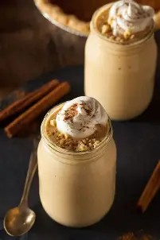
P U M P K I N P I E M I L K S H A K E

Ingredients:

2 cups vanilla ice cream (slightly softened)
¾ cup pumpkin puree
¼ cup + 1 - 2 tbsp brown sugar
½ - ⅔ cup milk (adjust to desired thickness)
1 tsp pumpkin pie seasoning whipped cream for serving
optional toppers- cinnamon, caramel, salt

Instructions:

Put two serving glasses into the freezer. A chilled glass helps keep the milkshake thick and frosty.
Add vanilla ice cream, pumpkin puree, brown sugar and milk to the blender.
blend until smooth and creamy, pausing to scrape down the sides if anything sticks.
add more brown sugar to taste and pumpkin pie seasoning. Continue blending until smooth and desired thickness (the more milk added, the thinner the shake).
Pour shake into chilled glasses. top each with whipped cream and other desired toppings.
Serve immediately with straw or long handled spoon.

