S C A L L O P E D P O T A T O E S

Ingredients:

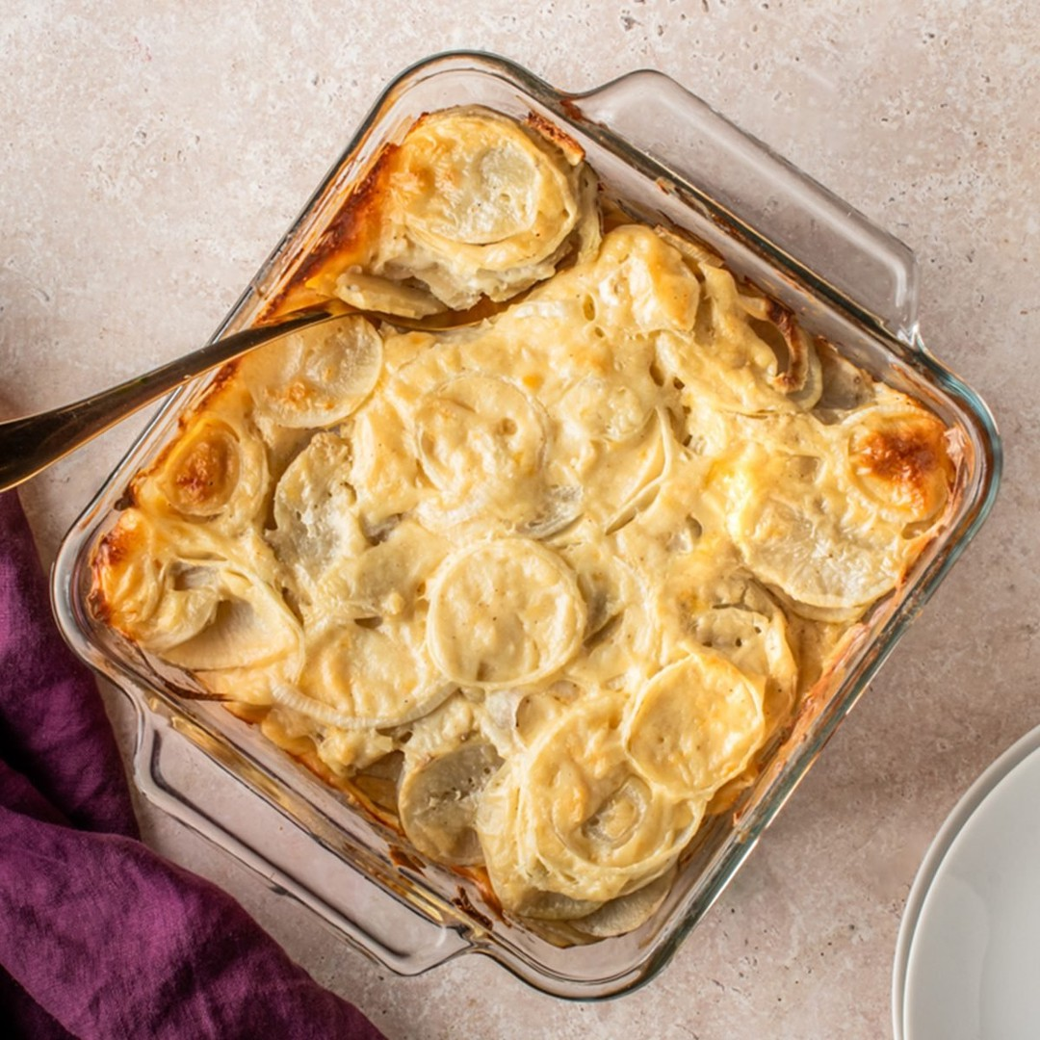
2 tablespoons butter
3 tablespoons all-purpose flour 1 teaspoon salt
1/4 teaspoon pepper
1-1/2 cups fat-free milk
1/2 cup shredded reduced-fat cheddar cheese
2 pounds potatoes, peeled and thinly sliced (about 4 cups)
1 cup thinly sliced onions, divided

Instructions:

Preheat oven to 350°. In a small saucepan, melt butter; stir in flour, salt and pepper until smooth. Gradually whisk in milk. Bring to a boil, stirring constantly; cook and stir until thickened, about 2 minutes. Remove from heat; stir in cheese until melted.
Coat an 8-in. square baking dish with cooking spray. Place half the potatoes in dish; layer with 1/2 cup onion and half the cheese sauce. Repeat layers.
Bake, covered, 50 minutes. Uncover; bake until bubbly and potatoes are tender, 10-15 minutes longer.

