S P I C E D A P P L E O A T M E A L

Ingredients:

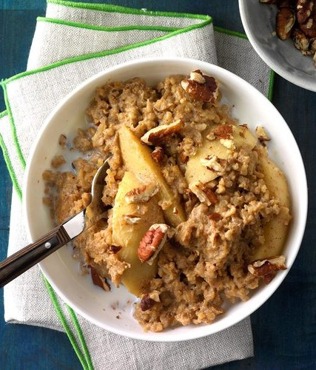
1/2 cup packed brown sugar 2 tablespoons lemon juice
2 tablespoons molasses
3 teaspoons ground cinnamon 1 teaspoon ground nutmeg
1/2 teaspoon ground ginger
1/2 teaspoon ground allspice 1/4 teaspoon salt
4 medium apples, peeled and cut into 1-inch slices
2 cups steel-cut oats 2 large eggs
2-1/2 cups water 2 cups milk
1 cup refrigerated vanilla dairy creamer
Optional: Chopped pecans and additional milk
Instructions:

Mix the first 8 ingredients. Place apples in a greased 4-qt. slow cooker. Top with brown sugar mixture, then with oats.
Whisk together eggs, water, milk and creamer; pour over oats. Cook, covered, on low until oats are tender, 4-1/2 to 5 hours. If desired, serve oatmeal with pecans and additional milk.

