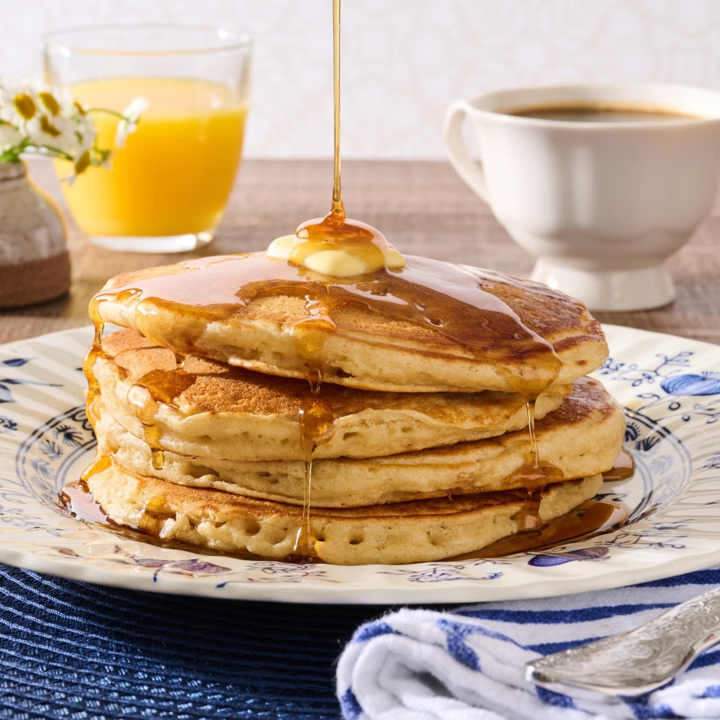
T H E P E R F E C T P A N C A K E

Ingredients:

2 cups all-purpose flour
4 generous Tbsp. granulated sugar 1 heaping Tbsp. baking powder
1/2 tsp. baking soda 1/2 tsp. salt (iodized)
1 1/4 cups whole milk, plus more as needed for thinning
3/4 cup buttermilk 1 large egg
1 Tbsp. vanilla extract
4 Tbsp. salted butter, melted, plus more for greasing griddle and serving
Maple syrup

Instructions:

In a large bowl, stir together the flour, sugar, baking powder, baking soda, and salt. In a separate bowl, whisk together the milk, buttermilk, egg, and vanilla. While whisking briskly, drizzle in the melted butter.
Using a rubber spatula, start gently stirring the dry ingredients while slowly pouring in the wet ingredients. Switch to folding once all the wet ingredients have been added to avoid overworking the batter. Continue folding until everything is combined. The batter should still be lumpy (don't try to stir the lumps out).
Important: Cover the bowl with plastic wrap and allow the batter to rest on the counter for 45 minutes to 1 hour. (If you don't have time, don't sweat it—they'll still be good.) Before frying, add up to 1/4 cup additional milk if you want thinner pancakes. (Or leave as is if you like them thick and fluffy.)
Heat a griddle or skillet over medium heat. Smear with butter and drop 1/3 cup (or 1/4 cup if you prefer smaller pancakes) helpings on the griddle. Let cook until bubbles form on the surface, then flip and cook for another 1 to 1 1/2 minutes. Serve with an obscene amount of butter and warm syrup.

